**Fairview Ltd. Announcement**

As part of the preparations for Fairview Ltd.’s upcoming 50th anniversary, Fairview is very pleased to announce they have updated their Corporate logo. The refreshed Fairview logo more suitably represents the modern, tech savvy, international, market leading image that they have evolved into over the last 50 years. To preserve Fairview’s rich history, the logo remains inside the widely recognized ellipse surrounding the Fairview name, but with a more modern look… and in keeping with tradition, they will continue to use their popular Black & Gold colours. The changeover to the new sleek design has already begun. This will soon be followed by the release of Fairview’s new “Flying F” short form logo, capitalizing on the Classic another great tool for Fairview to utilize in marketing campaigns, product packaging and sales initiatives going forward. Fairview’s new Corporate and Flying “F” logos create a tie, linking the two new designs to Fairview and its products. Fairview… Products for Industry, Service for people since 1969.

          Old                                  New                            Short Form Logo

**cid:image004.jpg@01D48317.08635100       cid:image005.png@01D48317.08635100               cid:image011.png@01D48317.08635100**

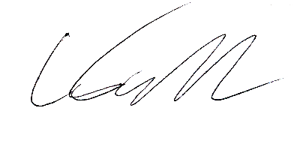 

Leslie Woodward Jim Forbes

President Vice President of Sales